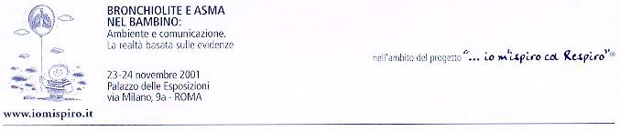
Bronchiolite e Asma nel Bambino – Rome 2001

Prophylaxis of RSV Infection: Past, Present and Future

Giovanni Piedimonte, M.D.

Professor of Pediatrics, Medicine and Molecular/Cellular Pharmacology
Director, Pediatric Pulmonology and Cystic Fibrosis Center

University of Miami School of Medicine

In the absence of effective treatment for respiratory syncytial virus (RSV) infection, prevention has become the preferred option to protect infants and young children against this common respiratory pathogen. In addition, the increasing body of evidence supporting a possible causative link between early RSV infections and asthma may add another potential benefit to the value of passive immunoprophylaxis.

Currently, only two options are available for the prevention of RSV infections in preterm-born infants and patients with bronchopulmonary dysplasia: a) infection control measures, such as hygiene and avoidance of passive exposure to cigarette smoke and crowded environments; and b) passive immunoprophylaxis with a humanized monoclonal antibody against RSV (palivizumab, Synagis). Ongoing multi-center trials are now testing the safety and efficacy of Synagis in patients affected by diseases involving increased risk for severe RSV disease. Specifically, double blind, placebo-controlled, randomized studies are being conducted in children with congenital heart disease, cystic fibrosis, and in bone marrow transplant recipients.

There is still a great need for active immunoprophylaxis with a universal RSV vaccine. Unfortunately, 44 years of research have not yet yielded a safe and protective vaccine, although efforts continue. The candidates furthest along in clinical trials are live attenuated virus vaccines. Several have proven immunogenic, but none is safe for infants less than one year of age. Other vaccine approaches include: subunit vaccines (potentially useful in older high-risk children, the elderly and in pregnant women) and genetically engineered vaccines (which are not yet in clinical trials). It appears that a safe and effective universal vaccine is still in the future.

Finally, recent epidemiological evidence supporting the role of early RSV infection as an important risk factor for the subsequent development of childhood asthma has boosted interest in the longer-term consequences of RSV prophylaxis. In particular, data obtained in animal models of RSV bronchiolitis suggest that Synagis protects the respiratory tract from persistent virus-induced inflammation when given before or in the early phase of the infection. Furthermore, 7-year follow-up data from a cohort of patients enrolled in an early trial with polyclonal immune globulin enriched for RSV-neutralizing antibodies (RespiGam) have revealed significant protection against long-term changes in pulmonary function and the frequency of asthma attacks. Thus, the administration of anti-RSV antibodies to high-risk infants may limit the severity of the acute airway inflammation as well as protecting against the respiratory sequelae associated with this virus.

Suggested further reading
IMpact-RSV Study Group. 1998. Palivizumab, a humanized respiratory syncytial virus monoclonal antibody, reduces hospitalization from respiratory syncytial virus infection in high risk infants, Pediatrics 102:531-537.
Englund, J. A. 1999. Prevention strategies for respiratory syncytial virus: passive and active immunization, Journal of Pediatrics 135:S38-S44.
Piedimonte, G., K. A. King, N. L. Holmgren, P. J. Bertrand, M. M. Rodriguez, R. L. Hirsch. 2000. A humanized monoclonal antibody against respiratory syncytial virus (palivizumab) inhibits RSV-induced neurogenic-mediated inflammation in rat airways, Pediatric Research 47:351-356.

