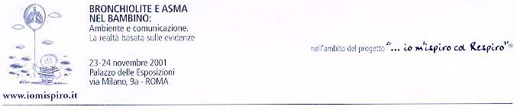

Effective doctor-patient communication:building a solid base for good compliance

Liesl M Osman
Senior Research Fellow
Department of Medicine and Therapeutics
University of Aberdeen/Chest Clinic
Aberdeen Royal Infirmary, Scotland.

What does it mean for a family when a child has asthma?
- Emotional impact - fear, problems in decision making.
- Social/activity interference - problems with everyday life
- Family functioning
- Impact on the child itself.

Three family stages in dealing with asthma

- being out of control
- being involved
- being in control

Patient questions when they learn they have asthma
- Why me?
- What happens now?
- How will this affect my life?
- What will happen in the future?

Asthma worries for children

Teenagers’ illness management

- Responsible ‘voluntary’ compliers
- Compelled compliers.
- Conscious non compliers.
- Frank refusers.

Conclusions

- Asthma has high impact on families.

- Families often do not receive good information to help gain control.

- Children may begin to manage their own asthma in middle childhood, and need to be consulted about their views.

- Focused education and assistance in self management helps families and children with asthma.

