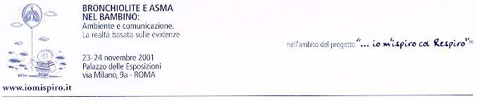

Pathogenesis of Bronchiolitis

G.J. Cropp, MD, Ph.D.

Professor of Clinical Pediatrics
University of California, San Francisco

October 2001

Bronchiolitis is an inflammatory, obstructive small airway disease. It is caused primarily by viral infections with respiratory syncytial (RSV) and parainfluenza types 1, 2 and 3 viruses, but influenza and adenovirus, chlamydia, mycoplasma and pertussis infections may also cause bronchiolitis.
While almost all children have been infected at least once by 2 years of age, they are at highest risk of developing severe disease during the first 6 months of life. Premature infants and those with chronic lung disease of the newborn, congenital heart disease, cystic fibrosis and congenital or aquired immune deficiency (chemotherapy, bone marrow or solid organ transplants, graft vs host disease) are at special risk. Male gender, low socioeconomic status, day care attendance, school age siblings, lack of breast feeding, crowded sleeping accommodations, passive tobacco smoke exposure, and birth 3 – 6 months before the onset of the winter viral season are additional risk factors. The natural temporary immune deficiency of prematurity and early life make infants especially vulnerable to develop viral bronchiolitis. Infants with acquired or congenital immune deficiency often shed virus for months.
Viruses incubate and replicate 2 – 8 days in the nasopharynx and then spread to the lower respiratory tract. Once in the lower respiratory tract, the virus causes edema, necrosis and sloughing of the epithelial airway lining and increased mucus secretion. The cellular debris, mucus and inflammed swollen airway walls obstruct the small airways causing fever, hyperinflation, atelectasis, airflow obstruction, cough and wheezing. RSV survives on skin, fomites, toys and counter tops. Handwashing and cleaning of toys, furniture and clothing will reduce the risk of transmission. Pneumonia, insterstitial infiltration and alveolar filling may develop, especially in the most severe cases and those who die. RSV infections elicit RSV-specific IgE production and parasympathetically mediated bronchial hyper- responsiveness. Complications include respiratory failure, bronchiolitis obliterans, bronchiectasis and death. 40 – 50% of infants who develop bronchiolitis that require hospitalization will wheeze with future respiratory tract infections until they reach 12 – 13 years of age. There is no strong evidence that RSV infections cause asthma.

